**Class name:** HelpPlace

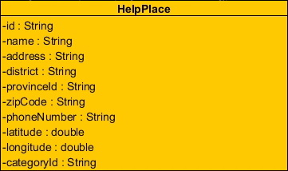

**Entities**

|  |  |  |  |
| --- | --- | --- | --- |
| **ID** | **Name** | **Description** | **Type** |
| 1 | id | stored id of the help place | string |
| 2 | name | stored name of the help place | string |
| 3 | district | stored district of the help place | string |
| 4 | provincesId | stored province id of the help place | string |
| 5 | zipCode | stored zipcode of the help place | string |
| 6 | phoneNumber | stored phone number of the help place | string |
| 7 | latitude | stored latitude of the help place | double |
| 8 | longitude | stored longitude of the help place | double |
| 9 | categoryId | stored category id of the help place | string |

**Class name:** HelpPlaceDAO

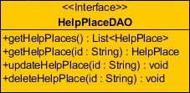

**Method details**

**Method name:** getHelpPlaces

public List<HelpPlace> getHelpPlaces ( )

**Description:** get help places from the database.

**Return:** List of the help place in database.

**Method name:** getHelpPlace

public HelpPlace getHelpPlace ( String id )

**Description:** get help place from the database.

**Parameter:** id-String uses for getting the help inforamtion.

**Return:** The help place in database.

**Method name:** updateHelpPlace

public void updateHelpPlace ( String id )

**Description:** update information of the help place to database.

**Parameter:** id-String uses for update information of the help place to database.

**Method name:** deleteHelpPlace

public void deleteHelpPlace ( String id )

**Description:** delete the help place from database.

**Parameter:** id-String uses for delete the help place from database.

**Class name:** HelpPlaceDAOImpl

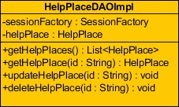

**Entities**

|  |  |  |  |
| --- | --- | --- | --- |
| **ID** | **Name** | **Description** | **Type** |
| 1 | sessionFactory | A thread-safe, immutable cache of compiled mappings for a single database | SessionFactory |
| 2 | helpPlace | Contained HelpPlace class for using method | HelpPlace |

**Method details**

**Method name:** getHelpPlaces

public List<HelpPlace> getHelpPlaces ( )

**Description:** get help places from the database by using session to query data.

**Return:** List of the help place in database.

**Method name:** getHelpPlace

public HelpPlace getHelpPlace ( String id )

**Description:** get help place from the database by using session to query data.

**Parameter:** id-String uses for getting the help information.

**Return:** The help place in database.

**Method name:** updateHelpPlace

public void updateHelpPlace ( String id )

**Description:** update information of the help place to database by using session to query data.

**Parameter:** id-String uses for update information of the help place to database.

**Method name:** deleteHelpPlace

public void deleteHelpPlace ( String id )

**Description:** delete the help place from database by using session to query data.

**Parameter:** id-String uses for delete the help place from database.

**Class name:** HelpPlaceService

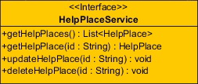

**Method details**

**Method name:** getHelpPlaces

public List<HelpPlace> getHelpPlaces ( )

**Description:** get help places from the database.

**Return:** List of the help place in database.

**Method name:** getHelpPlace

public HelpPlace getHelpPlace ( String id )

**Description:** get help place from the database.

**Parameter:** id-String uses for getting the help information.

**Return:** The help place in database.

**Method name:** updateHelpPlace

public void updateHelpPlace ( String id )

**Description:** update information of the help place to database.

**Parameter:** id-String uses for update information of the help place to database.

**Method name:** deleteHelpPlace

public void deleteHelpPlace ( String id )

**Description:** delete the help place from database.

**Parameter:** id-String uses for delete the help place from database.

**Class name:** HelpPlaceServiceImpl

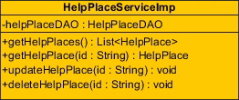

**Entities**

|  |  |  |  |
| --- | --- | --- | --- |
| **ID** | **Name** | **Description** | **Type** |
| 1 | helpPlaceDAO | Contained HelpPlaceDAO class for using method | HelpPlaceDAO |

**Method details**

**Method name:** getHelpPlaces

public List<HelpPlace> getHelpPlaces ( )

**Description:** get help places from the database through getHelpPlaces method of HelpPlaceDAO class.

**Return:** List of the help place in database.

**Method name:** getHelpPlace

public HelpPlace getHelpPlace ( String id )

**Description:** get help place from the database through getHelpPlace method of HelpPlaceDAO class.

**Parameter:** id-String uses for getting the help inforamtion.

**Return:** The help place in database.

**Method name:** updateHelpPlace

public void updateHelpPlace ( String id )

**Description:** update information of the help place to database through updateHelpPlace method of HelpPlaceDAO class.

**Parameter:** id-String uses for update information of the help place to database.

**Method name:** deleteHelpPlace

public void deleteHelpPlace ( String id )

**Description:** delete the help place from database through deleteHelpPlace method of HelpPlaceDAO class.

**Parameter:** id-String uses for delete the help place from database.

**Class name:** Category

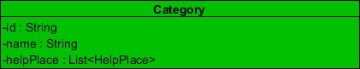

**Entities**

|  |  |  |  |
| --- | --- | --- | --- |
| **ID** | **Name** | **Description** | **Type** |
| 1 | id | stored id of the help place | string |
| 2 | name | stored name of the help place | string |
| 3 | helpPlace | stored list of the help place | List<HelpPlace> |

**Class name:** CategoryDAO

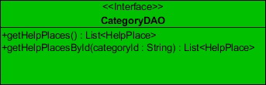

**Method details**

**Method name:** getHelpPlaces

public List<HelpPlace> getHelpPlaces ( )

**Description:** get help places from the database.

**Return:** List of the help place in database.

**Method name:** getHelpPlacesById

public List<HelpPlace> getHelpPlacesById (String category)

**Description:** get help places by id of category from the database.

**Return:** List of the help place in database.

**Class name:** CategoryDAOImpl

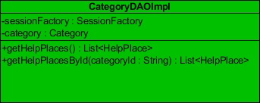

**Entities**

|  |  |  |  |
| --- | --- | --- | --- |
| **ID** | **Name** | **Description** | **Type** |
| 1 | sessionFactory | A thread-safe, immutable cache of compiled mappings for a single database | SessionFactory |
| 2 | category | Contained Category class for using method | Category |

**Method details**

**Method name:** getHelpPlaces

public List<HelpPlace> getHelpPlaces ( )

**Description:** get help places from the database by using session to query data.

**Return:** List of the help place in database.

**Method name:** getHelpPlacesById

public List<HelpPlace> getHelpPlacesById (String category)

**Description:** get help places by id of category from the database by using session to query data.

**Return:** List of the help place in database.

**Class name:** CategoryService

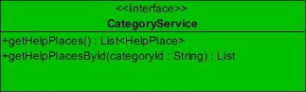

**Method details**

**Method name:** getHelpPlaces

public List<HelpPlace> getHelpPlaces ( )

**Description:** get help places from the database

**Return:** List of the help place in database.

**Method name:** getHelpPlacesById

public List<HelpPlace> getHelpPlacesById (String category)

**Description:** get help places by id of category from the database.

**Return:** List of the help place in database.

**Class name:** CategoryService

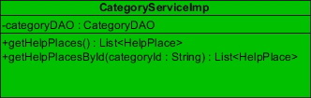

**Method details**

**Method name:** getHelpPlaces

public List<HelpPlace> getHelpPlaces ( )

**Description:** get help places from the database through getHelpPlaces method of CategoryDAO class.

**Return:** List of the help place in database.

**Method name:** getHelpPlacesById

public List<HelpPlace> getHelpPlacesById (String category)

**Description:** get help places by id of category from the database through getHelpPlacesById method of CategoryDAO class.

**Return:** List of the help place in database.

**Class name:** Province

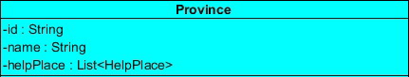

**Entities**

|  |  |  |  |
| --- | --- | --- | --- |
| **ID** | **Name** | **Description** | **Type** |
| 1 | id | stored id of the help place | string |
| 2 | name | stored name of the help place | string |
| 3 | helpPlace | stored list of the help place | List<HelpPlace> |

**Class name:** ProvinceDAO

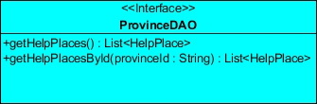

**Method details**

**Method name:** getHelpPlaces

public List<HelpPlace> getHelpPlaces ( )

**Description:** get help places from the database.

**Return:** List of the help place in database.

**Method name:** getHelpPlacesById

public List<HelpPlace> getHelpPlacesById (String province)

**Description:** get help places by id of province from the database.

**Return:** List of the help place in database.

**Class name:** ProvinceDAOImpl

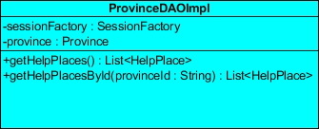

**Entities**

|  |  |  |  |
| --- | --- | --- | --- |
| **ID** | **Name** | **Description** | **Type** |
| 1 | sessionFactory | A thread-safe, immutable cache of compiled mappings for a single database | SessionFactory |
| 2 | province | Contained Province class for using method | Province |

**Method details**

**Method name:** getHelpPlaces

public List<HelpPlace> getHelpPlaces ( )

**Description:** get help places from the database by using session to query data.

**Return:** List of the help place in database.

**Method name:** getHelpPlacesById

public List<HelpPlace> getHelpPlacesById (String province)

**Description:** get help places by id of province from the database by using session to query data.

**Return:** List of the help place in database.

**Class name:** ProvinceService

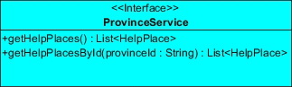

**Method details**

**Method name:** getHelpPlaces

public List<HelpPlace> getHelpPlaces ( )

**Description:** get help places from the database

**Return:** List of the help place in database.

**Method name:** getHelpPlacesById

public List<HelpPlace> getHelpPlacesById (String province)

**Description:** get help places by id of province from the database.

**Return:** List of the help place in database.

**Class name:** ProvinceServiceImpl

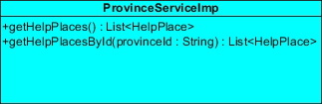

**Method details**

**Method name:** getHelpPlaces

public List<HelpPlace> getHelpPlaces ( )

**Description:** get help places from the database through getHelpPlaces method of ProvinceDAO class.

**Return:** List of the help place in database.

**Method name:** getHelpPlacesById

public List<HelpPlace> getHelpPlacesById (String province)

**Description:** get help places by id of province from the database through getHelpPlacesById method of Province DAO class.

**Return:** List of the help place in database.